CLUB TEE-SHIRTS NOW AVAILABLE
WITH SPECIAL 70TH BIRTHDAY BADGE
JUNIOR SIZES £10.00 EACH
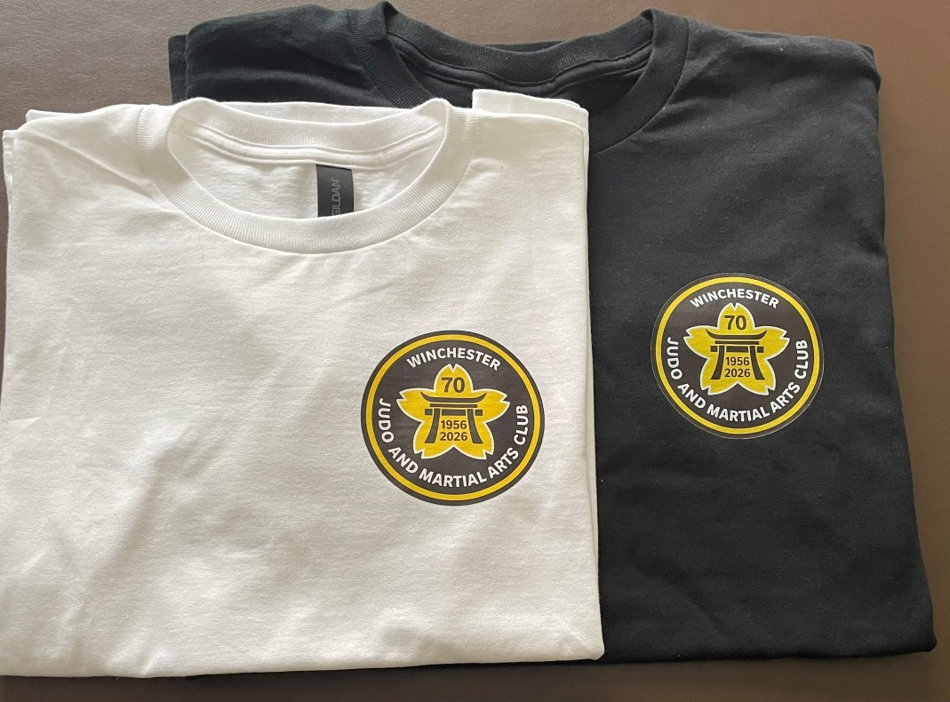
ADULT SIZES £15.00 EACH

SEE GLEN TO PLACE YOUR ORDER

